**Bug observation 1**

* Program does not swap the smallest word to the current word’s right side
* On line 139, the word being compared is not changing throughout the inner loop (constantly word[i])
* That caused the program to only find the last word that is smaller than the current word instead of the actual smallest word in this iteration
* Corrected as if(my_strcmporder(words[minIndex], words[j]) == 1)
* So that the smallest element is always changing as the iteration goes through

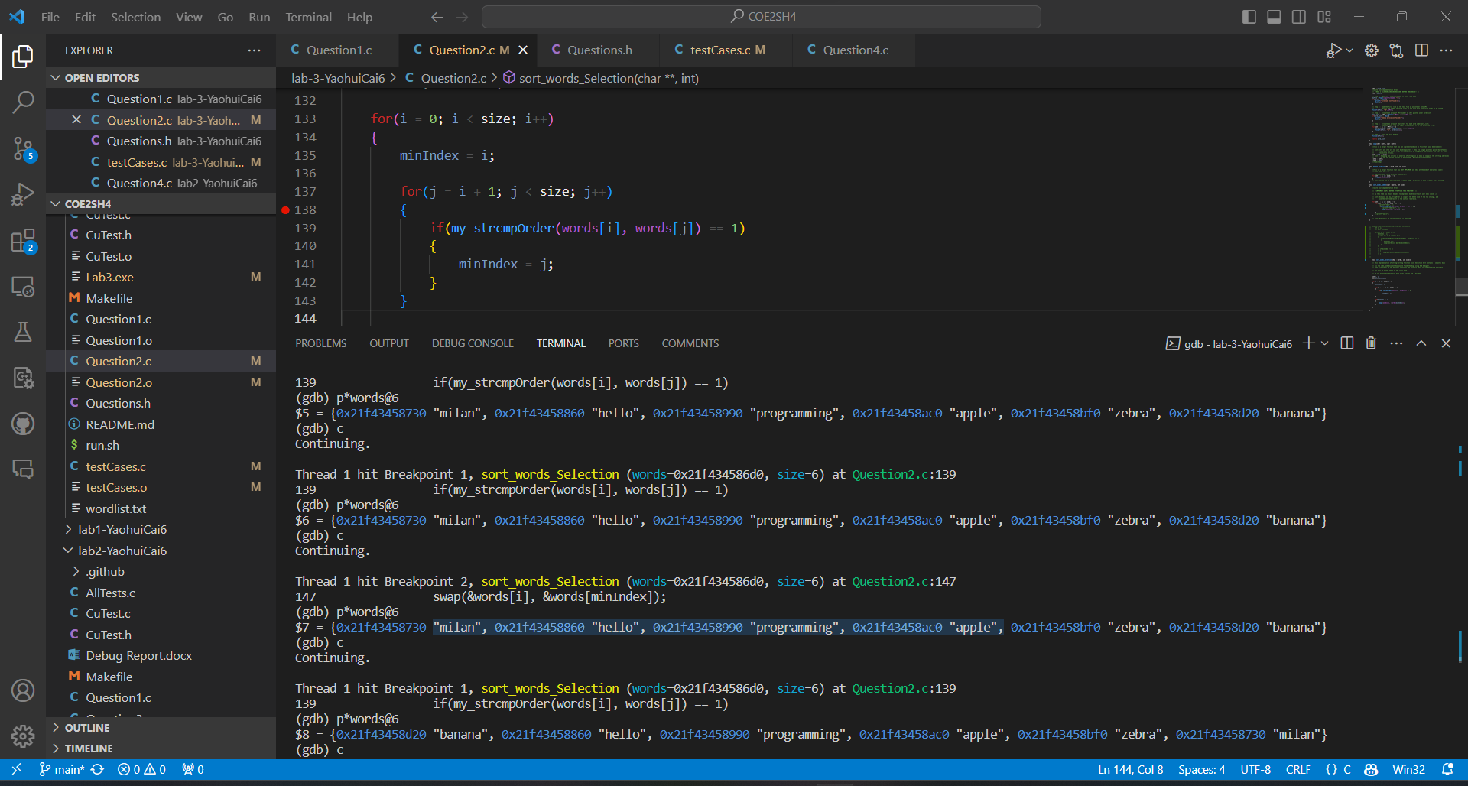

**Bug Observation 2**

* Program always execute the swap action when minIndex is not 6, regardless of whether the word needs to be swapped or not
* That is caused by the minIndex == j condition, in which case j will always be 6 after finishing a searching pass above
* Fix: replace j with i, word[i] is the correct current word being compared, therefore i should be checked against minIndex to know whether a swap should occur or not

